



Abstract: The COVID-19 pandemic is causing a worldwide emergency in healthcare. This virus mainly spreads through droplets which emerge from a person infected with corona-virus and poses a risk to others. The risk of transmission is highest in public places. One of the best ways to stay safe from getting infected is wearing a face mask in open territories as indicated by the World Health Organization (WHO). In this project, we propose a method which employs TensorFlow and OpenCV to detect face masks on people. A bounding box drawn over the face of the person describes weather the person is wearing a mask or not. If a person’s face is stored in the database, it detects the name of the person who is not wearing face mask and an email will be sent to that person warning them that they are not wearing a mask so that they can take precautions. In the near future, many public service providers will ask the customers to wear masks correctly to avail of their services. Therefore, face mask detection has become a crucial task to help global society. This paper presents a simplified approach to achieve this purpose using some basic Machine Learning packages like TensorFlow, Keras and, OpenCV. The proposed method detects the face from the image correctly and then identifies if it has a mask on it or not. As a surveillance task performer, it can also detect a face along with a mask in motion. The method attains accuracy up to 95.77% and 94.58% respectively on two different datasets. We explore optimized values of parameters using the Sequential Convolutional Neural Network model to detect the presence of masks correctly without causing over-fitting..

YESHWANTRAO CHAVAN COLLEGE OF ENGINEERING, NAGPUR.
(An autonomous Institution Affiliated to Rashtrasant Tukadoji Maharaj Nagpur University)
DEPARTMENT OF ELECTRONICS & TELECOMMUNICATION ENGINEERING
FACE MASK DETECTION
NAME OF THE STUDENTS: AAKIB SAYYAD, MOHIT ZADE, RITIK PUSDEKAR, ROHIT SAMARTH, TEJAS UBALE
NAME OF THE GUIDE: Prof. N.A PANDE
Session: 2021-22

Simulated Designs :
Methodology:   | Model Accuracy:  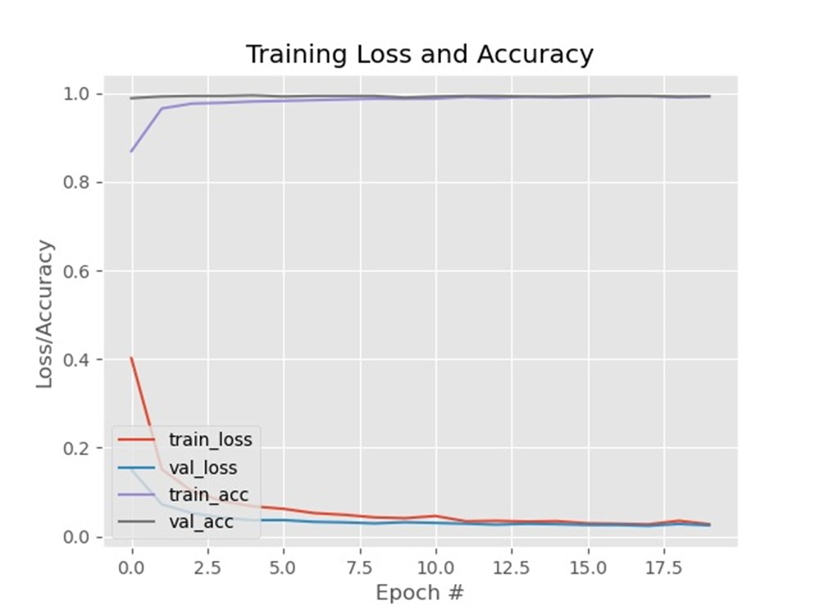

Introduction:
COVID-19 had a massive impact on human lives. The pandemic lead to the loss of millions and affected the lives of billions of people. Its negative impact was felt by almost all commercial establishments, education, economy, religion, transport, tourism, employment, entertainment, food security and other industries. According to WHO(World Health Organization), 55.6 million people were infected with
Coronavirus and 1.34 million people died because of it as of November 2020. After the person gets infected, it takes almost fourteen days for the virus to grow in the body of its host and affect them and in the meantime, it spreads to almost everyone who is in contact with that person. So, it is extremely hard to keep the track of the spread of COVID-19.
There are no efficient face mask detection applications to detect weather the person is wearing face mask or not. This increases the demand for an efficient system for detecting face masks on people for transportation means, densely populated areas, residential districts, large-scale manufacturers and other enterprises to ensure safety. This project uses machine learning classification using OpenCV and Tensorflow to detect facemasks on people.
Potential points of interest of the utilization of masks lie in reducing vulnerability of risk from a noxious individual during the “pre-symptomatic” period and stigmatization of discrete persons putting on masks to restraint the spread of virus. WHO stresses on prioritizing medical masks and respirators for health care assistants. Therefore, face mask detection has become a crucial task in present global society

Results: 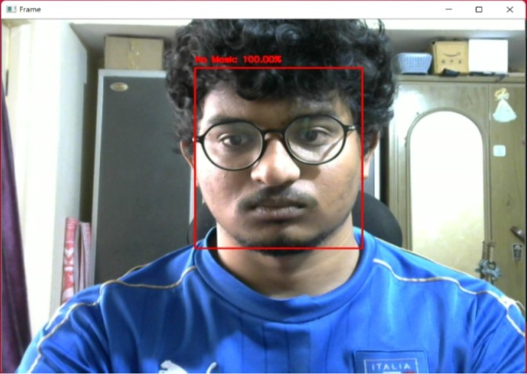 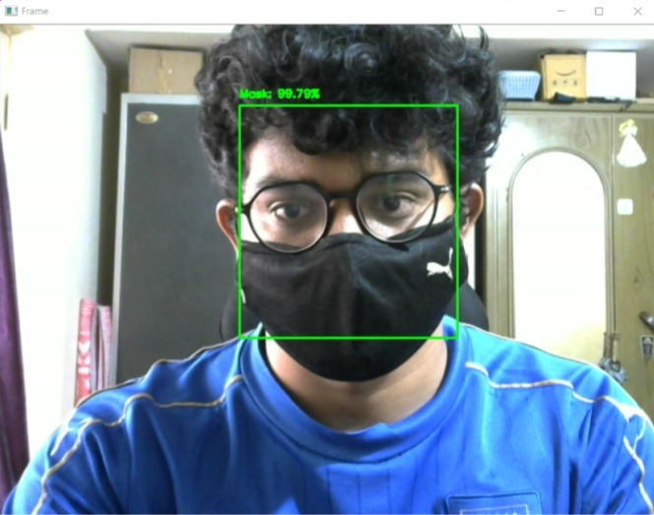

Before wearing Mask After wearing Mask
Conclusion:With the increasing number of COVID cases all over the world, a system to replace humans to check masks on the faces of people is greatly needed. This system satisfies that need. This system can be employed in public places like railway stations and malls. It will be of a great help in companies and huge establishments where there will be a lot of workers. This system will be of a great help there because it is easy to evaluate if the person is wearing a mask or not.

Future Scope:
The proposed system can be enhanced to detect multiple faces available on the screen using multi colour channels.

References:
[1] Covid-19 Face Mask Detection Using TensorFlow, Keras and OpenCv, Arjya Das,Mohammad Wasif Ansari,Rohini Basak, 2020
[2] An Approach to Face Detection and Recognition, Divya Meena,Ravi Sharan,2016
[3] Face Mask Detection Using OpenCV, Harish Adusumalli ,D Kalyani, 2021
[4] Advice on the use of masks in the context of COVID-19, WHO, 2020

